Lemon Drop Cupcakes

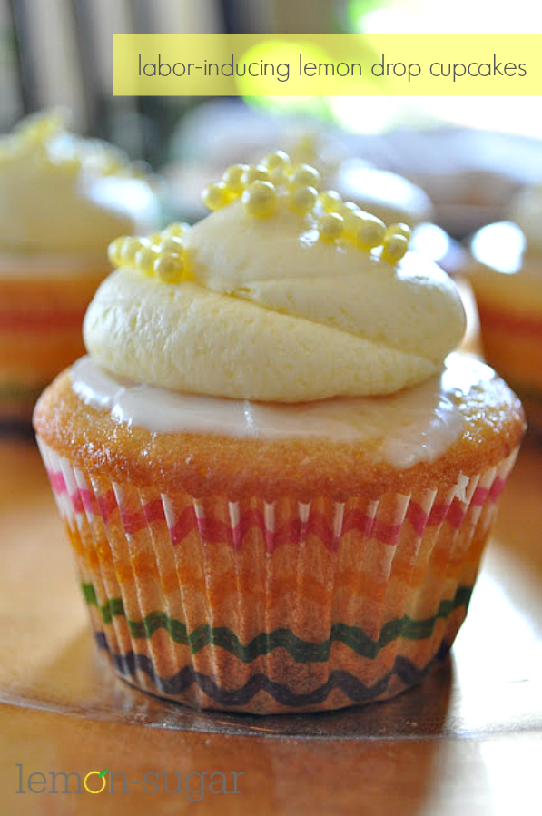

Prep time

60 mins

Cook time

20 mins

Total time

1 hour 20 mins

Rumor has it that these cupcakes will induce labor in full-term momma's! I think the trick is lots of fresh lemon juice! Enjoy!

Serves: Approximately 24 cupcakes

Ingredients

Cake Ingredients:

* 2 sticks unsalted butter at room temperature
* 2 cups white/granulated sugar
* 4 extra large eggs at room temperature
* ⅓ cup grated lemon zest (4-8 lemons, depending on size)
* 3 cups flour
* ½ teaspoon baking powder
* ½ teaspoon baking soda
* 1 teaspoon kosher salt
* ¼ cup freshly squeezed lemon juice
* ¾ cup buttermilk, at room temperature
* 1 teaspoon vanilla extract

Lemon Syrup Ingredients:

* ½ cup freshly squeezed lemon juice
* ½ cup white/granulated sugar

Glaze Ingredients:

* 2 cups powdered/confectioners sugar
* 3½ tablespoons freshly sqeezed lemon juice

Butter cream Ingredients:

* 2 sticks unsalted butter, softened
* 3 cups powdered/confectioners sugar
* ½ teaspoon salt
* 1 tablespoon plus 1 teaspoon milk
* 1 teaspoon pure vanilla extract
* 2 tablespoons fresh lemon juice

Instructions

Cake Directions:

1. Preheat oven to 350 degrees and prepare 24 cupcake tins with liners.
2. Cream the butter and sugar in bowl of stand mixer with the paddle attachment until light and fluffy, about 5 minutes.
3. Add the eggs one at a time, and lemon zest.
4. In another bowl, sift together flour, baking powder, baking soda and salt.
5. In another bowl, combine lemon juice, buttermilk and vanilla.
6. Add the flour mixture and the buttermilk mixture alternately to the batter, beginning and ending with the flour.
7. Using an ice cream scoop, fill each cupcake liner ½ full and bake for 18-20 minutes or until a toothpick comes out clean. Do not overbake!
8. Remove from oven and remove from cupcake pans as soon as possible. Let cool on a wire rack.
9. While the cupcakes are cooling, prepare the lemon syrup.

Syrup Directions:

1. Combine sugar and lemon juice in a heavy-bottom pan over low heat until sugar dissolves, stirring frequently.
2. After cakes have cooled for 10 minutes, spoon the syrup over the tops of the cupcakes, about a tablespoon of syrup per cake.
3. Then allow cakes to cool completely before glazing and frosting.

Glaze Directions:

1. Combine sugar and lemon juice in a bowl, mixing with a wire whisk until smooth.
2. Using the back of a large spoon, smooth some glaze over the top of each cupcake.
3. Each cupcake will use about ¾ teaspoon of glaze.

Buttercream Directions:

1. In the bowl of a stand mixer, cream the butter and salt for about 30 seconds.
2. Add the powdered sugar, milk, vanilla and lemon juice and beat 5-6 minutes until frosting is fluffy.
3. If desired, add some yellow (gel or icing) food coloring.
4. Add to piping bag and frost as desired.
5. Sprinkle with yellow sugar pearls, sugar, or a lemon drop candy for decoration.
6. Enjoy!!